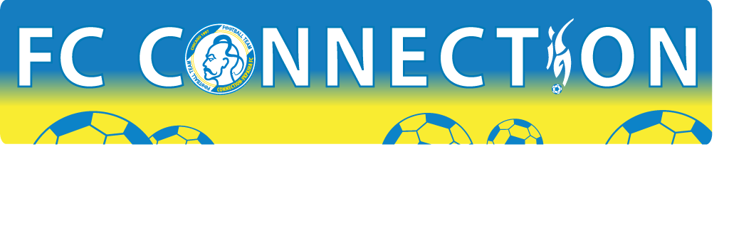
GREAT LAKES CUP XXI. CHICAGO, ILLINOIS, USA. MAY 27-MAY 28, 2017
PLAYER’S REGISTRATION FORM
 | Name(Last, First) | Address | D.O.B.  (m/d/y) | Signature
1.
2.
3.
4.
5.
6.
7.
8.
9.
10.
11.
12.
13.
14.
15
16.
17.
18.
Coach
Manager

I agree and will follow the Rules and Regulations of Great Lakes Cup 2017 Tournament in Chicago, IL, USA.

