Great Lakes Cup XXI
February 27, 2017

Dear Friends,

We are pleased to invite you to XXI Annual Great Lakes Cup Tournament, which will take place in our Windy City of Chicago, Illinois, USA on May 27-28, 2017. The teams from Detroit, Michigan; Toronto, Canada; Buffalo, New York; Cleveland, Ohio and Chicago, Illinois will compete again for the Main Trophy.
Traditionally, we will have 2 Divisions: Open and Over-35. Trophies to be awarded to the first and second place teams of each division. Additional trophies are to recognize the MVP, Top Goalscorer & Top Goalkeeper in each Division, accordingly.
First teams will play a minimum of 3 games, each consisting of two 25-minute halves. Over-35 teams will play a minimum of 2 games - 2 x 20 minutes in length. Games are played without the off-side rule. All other FIFA rules must be followed throughout the tournament.
The single entry fee for the team is $550.00; for multiple teams representing the same club $50.00 discount will apply for each team. Team Registration Form along with your payment must be submitted on or before April 01, 2017. Each participating team will receive coupons for 18 players, which can be redeemed for the purchase of food or drinks. Food and refreshments will be available for sale throughout the tournament.
Three guest players are permitted on each team, but they must have players’
Identification Cards from the team they are registered with. Out-of-state teams might need travel permits (check with your local soccer association for details).
Applications must be received by April 01, 2017. Registration and payment is available on our Facebook page @ FC Connection. Please, make check or money order payable to Connection-UA, NFP.
If you have any questions, please contact me at 708-473-5701 or at
tretyakfamily@sbcglobal.net

Sincerely,
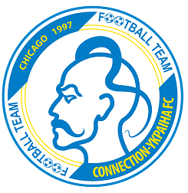
Roman Tretyak
CONNECTION-UA, NFP
Event Planner
1070 Bluebird Lane
Roselle, IL 60172

